

User’s Manual

Philip M. Knouff
Gerald I. Ottman III
Michael D. Bristol
William D. Whelchel II
Randy B. Akers
Radford University
Department of Information Technology
https://php.radford.edu~/softeng12
Date 4/19/2012

USER'S MANUAL
TABLE OF CONTENTS
Page #
1.0 GENERAL INFORMATION 1
1.1 System Overview 1
1.2 Project References 1
1.3 Authorized Use Permission 1
1.4 Points of Contact 2
1.4.1 Information 2
1.4.2 Coordination 2
1.4.3 Help Desk 2
1.5 Organization of the Manual 3
1.6 Acronyms and Abbreviations 3
2.0 SYSTEM SUMMARY 4
2.1 System Configuration 4
2.2 Data Flows 4
2.3 User Access Levels 4
2.4 Contingencies and Alternate Modes of Operation 4
3.0 GETTING STARTED…………………………………………………………………………………………………….5
3.1 Logging On 5
3.2 System Menu 5
3.2.1 Startup 5
3.2.2 Disclaimer 5
3.3 Changing User ID and Password 5
3.4 Exit System 5
4.0 USING THE SYSTEM 6
4.1 USING the SYSTEM (interactive/online) 6
4.1 Startup 6
4.2 Disclaimer 6
4.2.0 Formatting 6
4.2.1 Logger 7
4.2.2 List Instance 7
4.2.3 Display Instance 7
4.2.4 Random Instance 7
4.2.5 Tag Instance 8
4.2.6 Wait Time 8
4.2.7 Terminate 8
4.2 Special Instructions for Error Correction 8
4.3 Caveats and Exceptions 8
5.0 REPORTING 10
5.1 Reporting 10
5.2 Report Capabilities 10
5.3 Report Procedures 10
6.0 FUTURE ENHANCEMENTS 11
6.1 Future Functionality 11
6.2 Similar Systems – Additional Functionality 11
6.3 Maintenance Capabilities 11

1.0 GENERAL INFORMATION

GENERAL INFORMATION

1.1 System Overview

Turba Tech is a team formed from Radford University Department of Information Technology Software Engineering 3 class. Our system OpenHack is a major application which comes from an extension of the ChaosMonkey project in C#. Openhack is interpreted into python to be compatible with OpenStack Nova API rather than the Amazon Ec2 API. When running, the system will shut down random process on a specific server.

Major Functions
- Acceptance of Disclaimer
- Event Logging
- Search for Instance
- Search for Tag(Meta) in Instance
- Select Random Instance
- Delete Instance

Access to OpenHack is available through SSH connection through Radford University’s server Babbage2. All files and executables are accessible when a connection is made. OpenHack is started and executed by a command-line user interface. Currently OpenHack is still online and working.

1.2 Project References

Description | Link
Original ChaosMonkey source code | https://github.com/simonmunro/ChaosMonkey
Python documentation | http://python.org/
OpenStack Documentation | http://docs.openstack.org/
VersionOne | versionone.com
OpenStack python-novaclient API documentation | Reference/dir.text

1.3 Authorized Use Permission

OpenHack is written from an open source application based on ChaosMonkey. In turn any user is authorized in making reports, copies of data, and documents based of OpenHack. Permission to change any written functionality or code from OpenHack is first needed and can be done by submitting to the author the user’s update and ideas on the system. Malicious use of OpenHack is prohibited.

1.4 Points of Contact

1.4.1 Information

Below our (POCs) that may be contact at any time until April 27, 2012 from 12pm-315pm. After please contact Gabe Westmaas after this date.

Type | Name | Number | Email
Group Manager | William Whelchel | 540-850-2089 | wwhelchel@email.radford.edu
Tester | Randy Akers | 540-354-0869 | rbakers@email.radford.edu
Tester | Gerald Ottman | 434-841-0713 | gottman@email.radford.edu
Developer | Philip Knouff | 540-529-2643 | pknouff@email.radford.edu
Developer | Michael Bristol | 703-258-4061 | mdbristol@email.radford.edu
Supervisor(Professor) | Dr. Lewis | 540-831-5358 | tlewis32@RADFORD.EDU
Client | Gabe Westmaas | 540-831-9326 | gabe.westmaas@RACKSPACE.COM

1.4.2 Coordination

Dr. Lewis can be found during these times in Davis 229 for access to files stored on the school’s babbage2 server.
Office Hours:
Tues & Thur: 12:30pm – 2:00pm
Wed: 12:00 pm – 1:00pm and 2:00 pm – 3:00pm

Gabe Westmaas can be email or contacted Monday-Friday from 9am-5pm for information on OpenStack novaclient API.

1.4.3 Help Desk

For Radford University emergency contact on computer problems or any University IT systems, please contact the Technology Assistance center during these times below.

- Walk-in Support
Heth 157
Monday through Friday 8 a.m. – 5 p.m.
- Phone Support
(540) 831-7500
Monday through Friday 8 a.m. – 5 p.m.
Emergency classroom support is provided 7:30 a.m. to 10 p.m. Monday through Friday when classes are in session. Please call (540) 831-7500 Option 2.

For OpenStack troubles please contact Gabe Westmaas during his available time.
For General troubles you may contact either Developers listed above from 12pm-315pm until 4/26/2012, after please contact Dr. Lewis during her available times list above.

1.5 Organization of the Manual

Important Sections
- 3.0 Getting started
  - This section talks about how to begin and execute the system, and what users will see as they go through the system. First look at the functions of the system are described here.
- 4.0 Using the system
  - This section talks in detail about how each of the system functions work, how to use the system, and how the system finds and deletes processes from the server.

1.6 Acronyms and Abbreviations

Term | Definition
Test # | Test Case Number / Identifier
Requirement | Requirement that the test cases are validating (number / identifier)
Action | Action to perform or input to produce
Expected Result | Result expected when action is complete
Actual Result | What was actually seen
P / F | Pass / Fail indicator. Checkmark = Pass. “F” = Fail
Notes | Additional notes, error messages, or other information about the test.
OpenHack | The project referred to as a whole
OpenStack | The open-source web framework the system will be designed to operate on
EC2 | The Amazon cloud framework the original ChaosMonkey application ran on
Nova | The OpenStack API the system will interface with
Python | The Language the system will be coded in
C# | The language the original ChaosMonkey application was written in
IDE | Integrated Development Environment

SYSTEM SUMMARY

2.1 System Configuration

OpenHack was configured and developed on a Radford University server named babbage2 which connected to an OpenStack server hosted by RackSpace. By using babbage2 we were able to Secure Shell connect into the server very easily from any computer with a network connection.

2.2 Data Flows

Data is stored and maintained through logging done by OpenHack and is stored on the babbage2 server in the OpenHack directory in the openhack.log file. The log file can always be found in the OpenHack directory.

2.3 User Access Levels

Overall access to the use of OpenHack is available to any user with OpenStack credentials. A git tree is implemented for each of the developers which branches from the main system into each developer branch. Access to the developer's branch is restricted to only that developer and requires a password to access to his files and data in his branch.

2.4 Contingencies and Alternate Modes of Operation

On the event of a disaster or accident of the system, OpenHack can be installed on any computer for continued use of functions. The problem with this is that it can have serious effects on the computer and may cause the computer to crash with no backups possible. Only some functions would be allowed to operate under this condition. Radford University also backups all its servers into a secure location and we would be able to recover if a disaster occurred. If at any point these are not feasible solutions the overall operation on the system will not be possible until the problem or disaster is resolved.
3.0 GETTING STARTED

3.1 Logging On

OpenHack uses OpenStack to manage and execute the login functionality. To be able to use OpenHack you need to have received OpenStack Nova Credentials. These Credentials contain an API key which acts as the password, Username, Project_ID , URL to the server that will check your API key to give you access, Region name, and the version of nova client you will be using. Our system uses temporary OpenSack credentials that will give you access to the system until they are deleted where then you will be required to request credentials.

3.2 System Menu

3.2.1 Startup

The user will start OpenHack by running the executable “./openhack”. The user may specify a time duration between instance termination, by executing the executable by using “./openhack -w <wait time>”. If no time is provided the default time is set to five (5) seconds. The default number of instances to terminate is one.

3.2.2 Disclaimer
The disclaimer function, or in other words the start-up of the system, will require the user to accept the terms and warning of OpenHack and will require the user to accept these conditions in order to use the system. This is the only thing the user has to do to execute the system. The system will do the rest. The average response time should only take a couple of seconds after acceptance of the disclaimer.

3.3 Changing User ID and Password

The user may change the user ID or username by accessing the credentials located on OpenHack in the environment variables. The user can then change the username and project id only. The rest of the credentials cannot be changed unless you have received different credentials provided by the host of OpenStack.

3.4 Exit System

The system will exit after the user has accepted the disclaimer and the system has finished running, or the system will exit if the user does not accept the disclaimer.
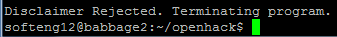

4.0 USING THE SYSTEM

4.1 USING the SYSTEM (interactive/online)

4.1 Startup

The user will start OpenHack by running the executable “./openhack”. The user may specify a time duration between instance termination, by executing the executable by using “./openhack -w <wait time>”. If no time is provided the default time is set to five (5) seconds. The default number of instances to terminate is one.

4.2 Disclaimer

The Screen Below depicts the execution and start of OpenHack. The user must input the correct letter which is case sensitive to begin execution of OpenHack. If any other input is entered the system will end. At either event a log is created or updated with the choice of the user. The rest of the functions of OpenHack are sub-functions where the user does not see the executing of the functions.

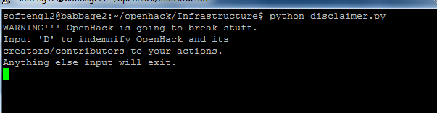

4.2.0 Formatting

Upon executing OpenHack the system requires at least one variable input from the command line.
Formats and Descriptions:

“./openhack –n <number of instances desired to be terminated>”
“./openhack –w <time(seconds)> –n <number of instances desired to be terminated>”
“./openhack –t <tag(Metadata)> –n <number of instances desired to be terminated>”
“./openhack –t <tag(Metadata)> –w <time(seconds)> –n <number of instances desired to be terminated>”

4.2.1 Logger

The Logging functionality is executed after every event that occurs including and after the Disclaimer function is ran. The Logging functionality requires first a place or file to keep track of all events logged which is located in the OpenHack directory under the name openhack.log. If the name is not already in the directory the log file is automatically created. The logger function takes five environmental inputs discussed in the Reporting section in 5.2. Refer to 5.1 for image and screen shot of the Logger in use.

4.2.2 List Instance

The List Instances function finds all the servers running at the time the disclaimer function is accepted. OpenHack then prints out the total number of instances found. Note that the user will not be able to see the instances found.

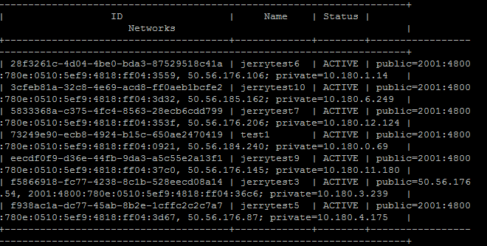

4.2.3 Display Instance

The Display Instances function prints out all the instances found from the List Instances.

4.2.4 Random Instance

The Random Instance function picks a server(s) from the list of instances found.

4.2.5 Tag Instance

The tag instance function searches for instances with the tag (found in Metadata) associated with the instance. The user will be able to input the tag(Metadata) to search for within the instances found from the list instance function by using the executable “./openhack –w <wait time> –t <tag name>”.

4.2.6 Wait Time

The wait time function allows a user to input the amount of time to wait in between terminating instances. The user may enter nothing which at that time will call the default wait time of five seconds.
Format: “./openhack –w <wait time>”

4.2.7 Terminate

OpenHack randomly selects an instance(s) and then terminates that instance(s). Termination may take time depending on a number of factors which lie outside the scope of our system.

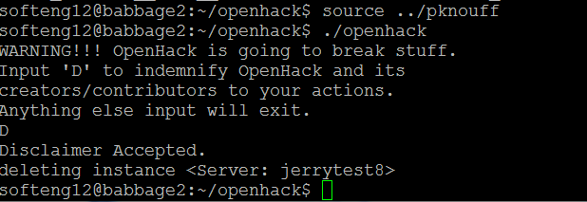

4.2 Special Instructions for Error Correction

At this time our system has no special instructions for making corrections on any errors that occur in our system. Look at section 6.1 for more information.

4.3 Caveats and Exceptions

The user must make sure the environment variables are set up for the credentials to ensure that the system runs properly. Please see the link below on more information on environment variables.

Link: https://github.com/openstack/python-novaclient#command-line-api

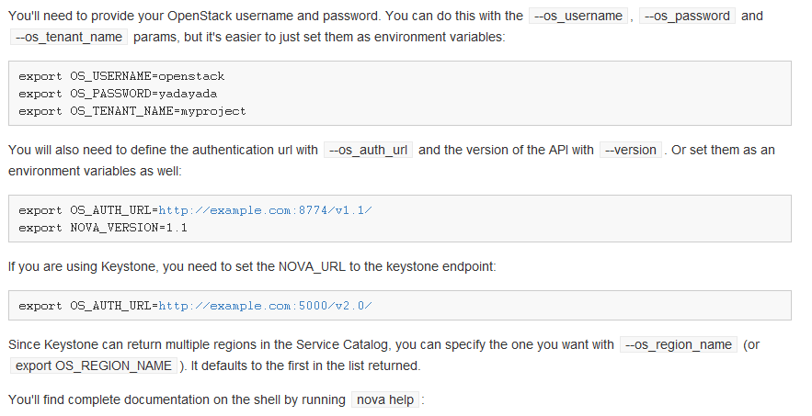

5.0 REPORTING

5.1 Reporting
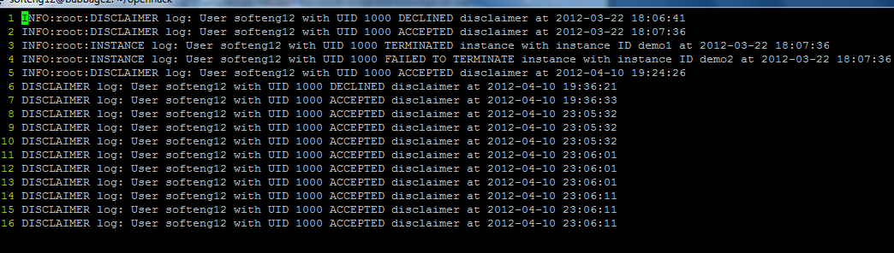

5.2 Report Capabilities

The user may access reports or logs generated by the system. These logs contain information on events caused by the system. Each log contains five environmental inputs which include the event, user, ID, what happened, and the time at which this event occurred. The system creates these reports in an XML format.

5.3 Report Procedures

Logs are created for each function or event and are outputted into an XML file. To access these reports you need to access the OpenHack directory where then you open the file openhack.log in any editor to review or print out the logs created by the system. These logs are created to give the user the ability to troubleshoot errors or problems with the system if an error would occur. It also gives the use the ability to check to see that the system does what it’s supposed to do.

6.0 FUTURE ENHANCEMENTS

6.1 Future Functionality

Further development of OpenHack would allow a user to choose a process to delete rather than having a process randomly chosen. A user interface could be added to give the user a step by step demonstration of what our system is doing. Giving the user the ability in the system to be able to add or delete tags (Meta) of processes at the startup of the system. A system or documentation to support errors caused from OpenHack could be created to troubleshoot for error corrections. Searching for a tag (MetaData) was not able to be fully implemented for the future can be added to improve performance.

6.2 Similar Systems – Additional Functionality

- Another improvement that can be added to the system is the ability to SSH into the system with a username and password without inputting the credential manually.
- Stackmonkey - http://wiki.openstack.org/stackmonkey
- Making the system into a Daemon which runs in the background of the server.

6.3 Maintenance Capabilities

By keeping backup of all previous version of OpenHack as well updated commented code, OpenHack will be able to be improved and maintained for years to come.

